TO: Principal Investigators on SRAC Projects

SUBJECT: REQUEST FOR NO-COST EXTENSION OF TIME

The project participant should strive to complete work on the project within the time frame specified in the project proposal. Circumstances beyond the control of project participants may, however, make it necessary to request additional time to complete project activities. Under such circumstances, SRAC will consider a request for a no-cost extension of time to complete work on the project objective. Such requests must be made in writing before the expiration date of the subcontract. (Important note: the fact that funds are expected to be unobligated at the expiration of the subcontract is not a sufficient justification for an extension!)

The request must contain, at a minimum, the following information:
- The length of additional time needed to complete the project objective (normally no more than three months);
- A justification for the extension;
- A concise summary of progress made to date; and
- An estimate of the funds expected to remain unobligated on the scheduled expiration date.

As Principle Investigator, you should submit the request to the SRAC Director for review and approval prior to the termination date of the project. If you have additional questions concerning this budget revision, please contact Kristen Thompson at 662-686-3269 or srac@drec.msstate.edu.

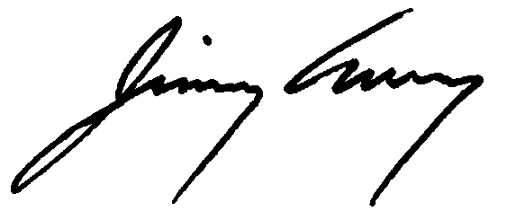
Sincerely,

Jimmy Avery, Ph.D.
Director, USDA NIFA Southern Regional Aquaculture Center
Extension Professor, National Warmwater Aquaculture Center
Mississippi State University
662-686-3273
jimmy.avery@msstate.edu

DATE:

TO: Jimmy Avery. Director, SRAC

SUBJECT: No-cost extension for Year __ of SRAC Project “(Title of Project)”

I would like to request a no-cost extension of time for the (Name of Institution) portion of Year X of the SRAC project “(Title of Project)” from (current termination date) to (requested termination date).

This no-cost extension is necessary because (explain the basis for the request).

REQUESTED BY: APPROVED:

_________________________________ _________________________________
Principal Investigator Date Jimmy Avery, Director, SRAC Date

